JUNE 2013- Art
SUNDAY | MONDAY | TUESDAY | WEDNESDAY | THURSDAY | FRIDAY | SATURDAY
 |  |  |  |  |  | 1
2 | 3 | 4 | 5  Last Day of School for Buncombe County | 6  FIRST DAY OF SUMMER CAMP!  WELCOME!! | 7 | 8
9  NATIVE  AMERICAN  ART | 10 | 11  RAD 4 CLAY | 12 | 13 | 14  CHEROKEE  VILLAGE | 15
16 | 17  WNC NATURE CENTER | 18  SONIA- DRUMMING | 19 | 20  ART SHOW ON CAMPUS!!! | 21  WATER PARK FIELD TRIP | 22
23  ASIAN ART | 24 | 25  RAD 4 CLAY | 26 | 27  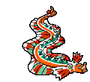 | 28  ARBORETUM | 29
30

JULY 2013- Art
SUNDAY | MONDAY | TUESDAY | WEDNESDAY | THURSDAY | FRIDAY | SATURDAY
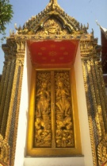 | 1  KASUMI MTN. | 2   | 3  ART SHOW ON CAMPUS!!! | 4  HAPPY INDEPENDENCE DAY!!!  CLOSED | 5  YOSHIDA | 6  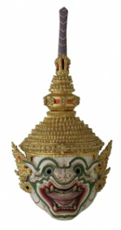
7 | 8 | 9 | 10 | 11 | 12 | 13
14 | 15 | 16 | 17 | 18 | 19 | 20
21  NATIVE AMERICAN ART | 22 | 23  RAD 4 CLAY | 24 | 25 | 26  CHEROKEE VILLAGE | 27
28 | 29  WNC NATURE CENTER | 30 | 31
AUGUST 2013- Art
SUNDAY | MONDAY | TUESDAY | WEDNESDAY | THURSDAY | FRIDAY | SATURDAY
 |  |  |  | 1  ART SHOW ON CAMPUS!!! | 2  FUN DEPOT | 3
4  MODERN ART | 5  Afterschool Registration Begins Today! | 6  ASHEVILLE FACE AND BODY PAINTING | 7 | 8 | 9  ART MUSEUM VISIT | 10
11 | 12   | 13 | 14 | 15  FIELD DAY!  Games, Races and Treats on Ball Field. | 16  WATER PARK/ TUBING |   17
18 | 19 | 20  Last day of summer camp! | 21  Back to School for Buncombe County Students!  (Afterschool begins today) | 22 | 23 | 24
25 | 26 | 27 | 28 | 29 | 30 | 31

